**LAPORAN**

**PROJECT UAS ALGORITMA & PEMROGRAMAN 2**

**”SELECTION SORT DAN SEARCHING”**



**UAS GENAP 2021/2022**

oleh:

**NAMA : Fathurrohman Solehudin**

**KELAS : 2A**

**NIM : 21040012**

**PROGRAM STUDI DIII TEKNIK KOMPUTER**

**POLITEKNIK HARAPAN BERSAMA**

**2022**

1. **Script**

/*

Nim : 21040012

Nama : Fathurrohman Solehudin

Kelas : 2A

*/

#include <iostream>

#include <iomanip>

#include <conio.h>

#include <windows.h>

using namespace std;

void gotoxy(int x, int y)

{

COORD coord;

coord.X = x;

coord.Y = y;

SetConsoleCursorPosition(GetStdHandle(STD_OUTPUT_HANDLE),

coord);

}

struct uas

{

int price, stock, kode;

string nm;

};

void intro(){

login:

int nim;

string nama,kelas;

cout<<"Login Terlebih dahulu"<<endl;

cout<<"NIM : "; cin>>nim;

cout<<"Nama : "; cin.ignore();getline(cin,nama);

cout<<"Kelas : "; cin>>kelas;

cout<<"================================================================"<<endl;

cout<<"Login Sukses...";

getch();

}

int main(){

cout<<"\t\t"<<"=================================================================================="<<endl;

cout<<"\t\t"<<"| PROGRAM SORTING DAN SEARCHING BARANG GUDANG |"<<endl;

cout<<"\t\t"<<"=================================================================================="<<endl;

cout<<"\t\t"<<"| FATHURROHMAN SOLEHUDIN |"<<endl;

cout<<"\t\t"<<"| 2140012 |"<<endl;

cout<<"\t\t"<<"=================================================================================="<<endl<<endl;

intro();

data:

system("cls");

cout<<"By: FathurrohmanS"<<endl<<endl;

int n;

cout<<"Masukan jumlah barang : "; cin>>n;

if (n >= 10 && n <=20)

{

} else if (n < 10)

{

cout<<"Data yang anda masukan kurang dari 10"<<endl;

getch();

system ("cls");

goto data;

} else if (n > 10)

{

cout<<"Data yang anda masukan lebih dari 20"<<endl;

getch();

system ("cls");

goto data;

}

cout<<"================================================================"<<endl;

cout<<"================================================================"<<endl;

uas toko[n];

int kode[n];

for (int i = 0; i < n; i++)

{

cout<<"Masukan data barang ke-"<<i+1<<endl;

cout<<"Kode Barang : "; cin>>toko[i].kode;

kode[i]=toko[i].kode;

cin.ignore(1,'\n');

cout<<"Nama Barang : "; getline(cin,toko[i].nm);

cout<<"Stok Barang : "; cin>>toko[i].stock;

cout<<"Harga Barang : "; cin>>toko[i].price;

cout<<"================================================================"<<endl;

}

system ("CLS");

cout<<"By: FathurrohmanS"<<endl<<endl;

cout<<"+=============+============================+======+==============+\n";

cout<<"| Kode Barang | Nama Barang | Stok | Harga Satuan |\n";

cout<<"+=============+============================+======+==============+\n";

for (int i=0; i<n; i++) {

gotoxy (0, 5+i);cout<<"| "<<toko[i].kode;

gotoxy(14, 5+i);cout<<"| "<<toko[i].nm;

gotoxy(43, 5+i);cout<<"| "<<toko[i].stock;

gotoxy(50, 5+i);cout<<"| "<<toko[i].price;

gotoxy(65, 5+i);cout<<"|"<<endl;

}

//menampilan kode barang yang sudah urut

cout<<"+=============+============================+======+==============+\n";

cout<<"Urutkan sesuai kode barang : . . ."<<endl;

getch();

int a,b,c,kosong;

for (int i= n-1;i>=0;i--)

{

a=0; b=kode[0];

for (int j=1;j<=i;j++)

{

if (kode[j]>b)

{

a=j; b=kode[j];

}

}

kosong=kode[i];

kode[i]=b;

kode[a]=kosong;

for (int c=0; c < n; c++)

{

kode[c];

}

}

system("cls");

cout<<"By: fathur"<<endl<<endl;

cout<<"+=============+============================+==============+======+\n";

cout<<"| Kode Barang | Nama Barang | Harga Satuan | Stok |\n";

cout<<"+=============+============================+==============+======+\n";

for (int i = 0; i < n; i++)

{

for (int j = 0; j < n; j++)

{

if (kode[i] == toko[j].kode)

{

gotoxy (0, 5+i);cout<<"| "<<kode[i];

gotoxy(14, 5+i);cout<<"| "<<toko[j].nm;

gotoxy(43, 5+i);cout<<"| "<<toko[j].price;

gotoxy(58, 5+i);cout<<"| "<<toko[j].stock;

gotoxy(65, 5+i);cout<<"|"<<endl;

}

}

}

cout<<"+=============+============================+==============+======+\n";

//memulai untuk melakukan pembelian

cout<<"Masukan 3 transaksi "<<endl;

int search[3],qty[3],tbar[3]={};

string P;

for (int i = 0; i < 3; i++)

{

cout<<"Masukan Kode Barang : "; cin>>search[i];

for (int j = 0; j < n; j++)

{

if (search[i]==toko[j].kode)

{

cout<<"Nama Barang : "<<toko[j].nm<<endl;

cout<<"Harga Barang : "<<toko[j].price<<endl;

cout<<"Jumlah barang : "; cin>>qty[n];

tbar[i] = toko[j].price * qty[n];

cout<<"Total Barang : "<<tbar[i]<<endl;

P="";

break;

} else

{

P="Kode Barang tidak ditemukan\n";

}

}

cout<<P;

cout<<"================================================================"<<endl;

}

//diskon

int tbel = tbar[0] + tbar[1] + tbar[2];

cout<<"TOTAL BELI : "<<tbel<<endl;

int total;

if (tbel > 160000 && tbel <= 250000)

{

total = tbel - (0.02 * tbel);

cout<<"Mendapat diskon 2%"<<endl;

} else {

if (tbel > 250000 && tbel <= 500000)

{

total = tbel - (0.05 * tbel);

cout<<"Mendapat diskon 5%"<<endl;

} else {

if (tbel > 500000)

{

total = tbel - (0.1 * tbel);

cout<<"Mendapat diskon 10%"<<endl;

} else

{

total=tbel;

}

}

}

//transaksi

transaksi:

cout<<"================================================================"<<endl;

cout<<"Total bayar: "<<total<<endl;

int saldo,kembalian;

cout<<"saldo \t: "; cin>>saldo;

if (saldo < total)

{

kembalian = saldo - total;

cout<<"Saldo anda kurang "<<kembalian; cout<<endl;

cout<<"================================================================"<<endl;

goto transaksi;

}

if (saldo >= total) {

kembalian = saldo - total;

cout<<"Saldo kembalian anda : "<<kembalian; cout<<endl;

cout<<"================================================================"<<endl;

}

return 0;

}

**B. HASIL RUNNING PROGRAM**

**a). Selesai memasukkan Kelas**

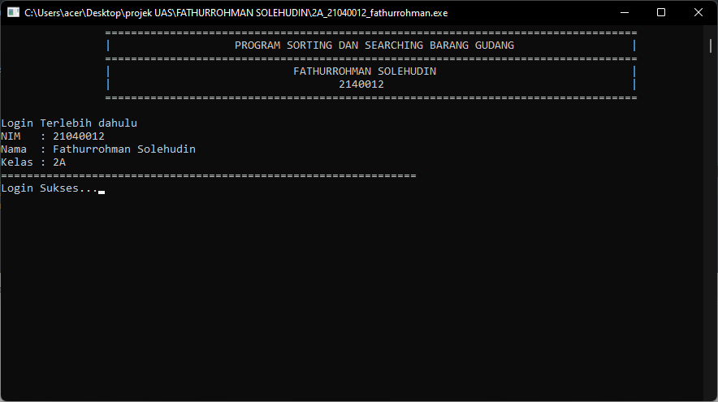

**b). Tampilkan data ke-5**

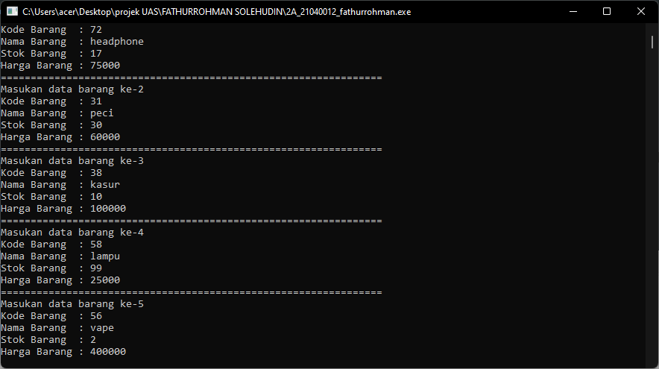

**c). Tampilan data sebelum diurutkan**

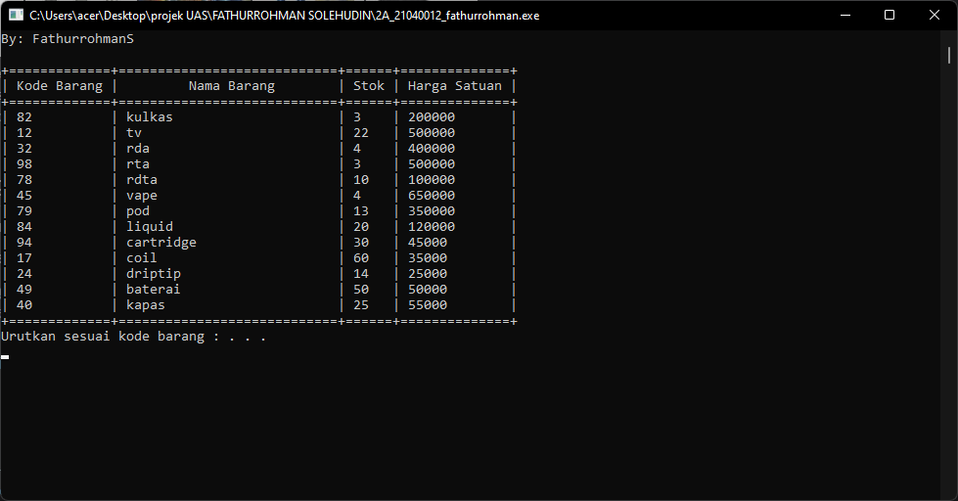

**d). Tampilan data setelah di urutkan**

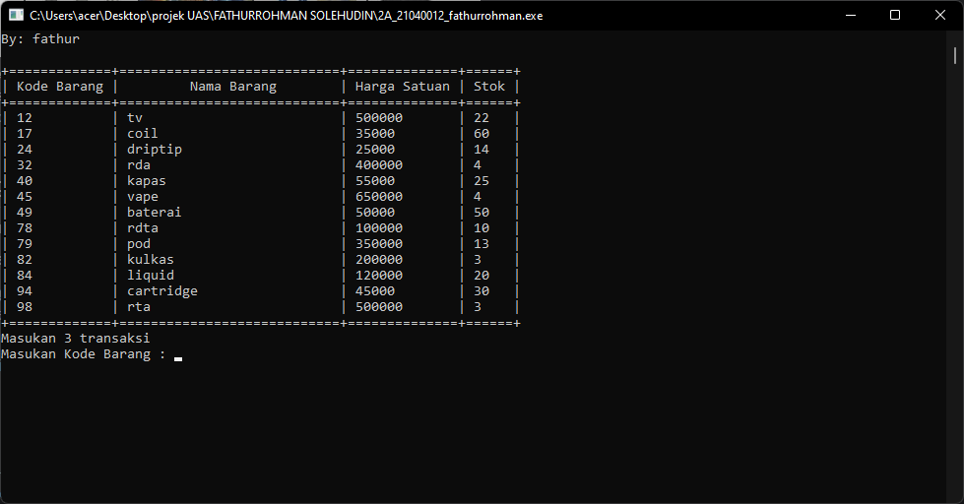

**e). Transaksi data ke-2**

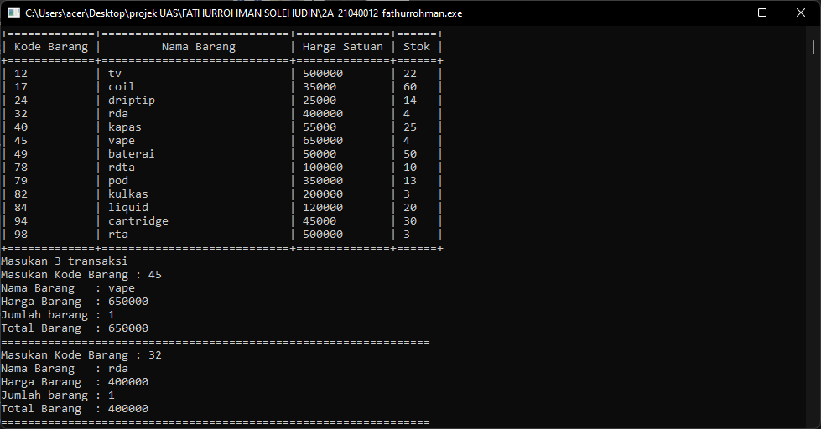

**f). Menampilkan jumlah yang dibayar**

